EXPT NO:5 | DASHBOARD DESIGNING
DATE: 24.01.2026 | DASHBOARD DESIGNING

PRE-LAB QUESTIONS
- How do dashboards support strategic decision-making?
Ans: • Provide real-time insights
• Summarize large data into KPIs
• Help identify trends, risks, and opportunities
• Enable data-driven decisions instead of intuition

- What role do dashboards play in AI monitoring systems?
Ans: • Monitor model performance and accuracy
• Track anomalies and system behaviour
• Visualize AI outputs and predictions
• Support early detection of failures

- Why is interactivity essential in modern dashboards?
Ans: • Allows filtering and drill-down
• Enables user-specific analysis
• Improves exploration of data
• Makes dashboards dynamic and flexible

- What cognitive overload issues exist in dashboards?
Ans: • Too many visuals at once
• Excessive colours and text
• Unclear KPIs
• Poor layout causing confusion and fatigue

- How are KPIs derived from raw data?
Ans: • Raw data is cleaned and aggregated
• Important metrics are identified
• Mathematical measures (average, sum, ratio) are applied
• Results are converted into meaningful indicators

OBJECTIVE: To design an interactive analytical dashboard for monitoring key metrics.

SCENARIO: An AI-based smart campus system requires a dashboard to monitor attendance, academic performance, and resource utilization in real time.

IN-LAB TASKS (Using Power BI)
• Design KPI cards for attendance and performance
• Implement filters by department and semester
• Link multiple views for drill-down analysis

Dashboard Design:
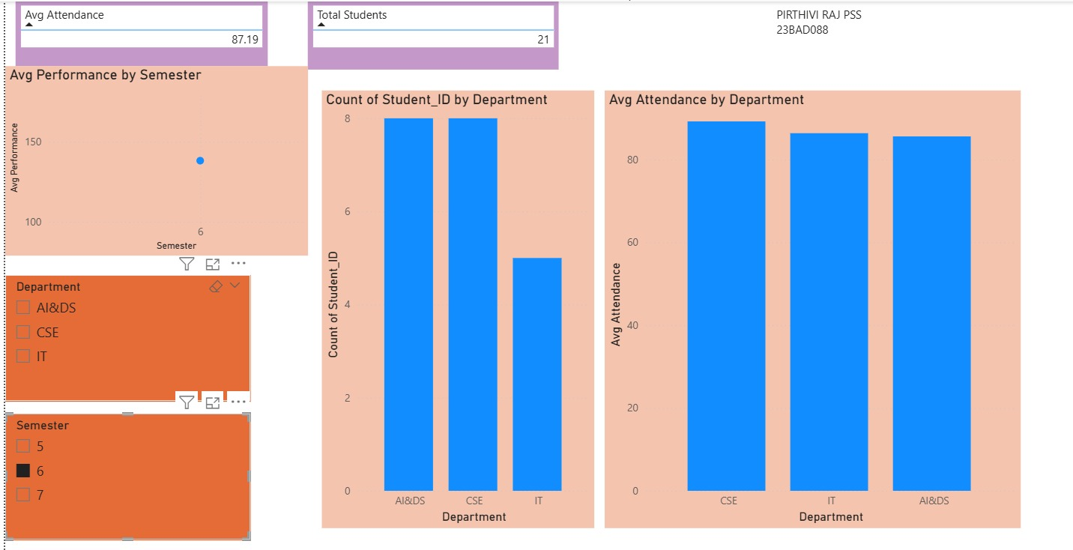

POST-LAB QUESTIONS
- How does interactivity improve analytical depth?
Ans: • Enables multi-level analysis
• Allows focused exploration
• Helps uncover hidden patterns
• Supports what-if analysis

- Which KPIs are critical for academic monitoring?
Ans: • Attendance percentage
• Internal assessment performance
• Assignment scores
• Pass/fail or grade distribution

- What design principles prevent information overload?
Ans: • Minimal visuals
• Clear hierarchy
• Consistent colours
• Use of summaries instead of raw data

- How can dashboards be integrated with AI alerts?
Ans: • Use threshold-based triggers
• Generate alerts for abnormal patterns
• Integrate with notification systems
• Enable real-time AI-driven insights
- How do dashboards enhance transparency in institutions?
Ans: • Provide open access to performance data
• Improve accountability
• Support informed decision-making
• Build trust among stakeholders

LEARNING OUTCOME: Students understand dashboard design for AI-driven environments.
ASSESSMENT
Description | Max Marks | Marks Awarded
Pre Lab Exercise | 5
In Lab Exercise | 10
Post Lab Exercise | 5
Viva | 10
Total | 30
Faculty Signature

